2nd Qt. Study Guide
Name: _________________ Bell: _____
Part #1: pH
- What pH number indicates an alkali? _____
- What ph number indicates an acid? _____
- What ph number indicates a neutral substance? _____
- Describe neutralization. __________________________
________________________________________________
________________________________________________
- In general, what types of substances tend to be acidic? ____________________________________________
- In general, what types of substances tend to be alkali? ____________________________________________

Part #2: Waves & Sound
Define the following vocabulary terms:
8. Amplitude: ______________________________________
9. Wavelength: _____________________________________
10. Frequency: ______________________________________
11. Compression: _____________________________________
12. Rarefaction: _____________________________________
13. How many full wavelengths are there in the wave below? ____
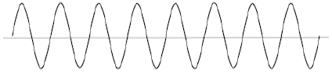

14. How many full wavelengths are there in the wave below? ____

15. What role does energy play in sound? ________________________________________________________________________________________________________________________
16. What sort of frequency do high-pitched sounds have? ______
17. Which aspect of sound goes with pitch? _______________
18. Which aspect of sound goes with volume? _______________
19. What type of energy is sound? ______________________

20. Label the wavelength, trough, crest, and amplitude of the wave.
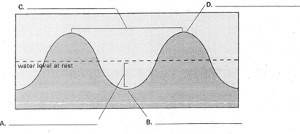
21. Which of the following waves below has more energy? How do you know? ___________________________________________________________
___________________________________________________________
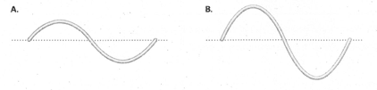
22. Sketch a wave with higher frequency & higher amplitude than wave A. above.
Part #3: Circuits
Define the following vocabulary terms:
23. Series circuit: ___________________________________
24. Parallel circuit: __________________________________
25. What causes electricity? ___________________________
26. What type of charge do electrons have? _______________

27. In the space below, draw a parallel circuit and a series circuit. Make sure you include and label a bulb, switch, and a battery.

Part 4: Vocabulary Energy Transfer
- Kinetic Energy D. Nuclear Energy
- Mechanical Energy E. Electromagnetic Energy
- Potential Energy

- _____ Energy transmitted through space in the form of electromagnetic waves.
- _____The energy of motion.
- _____A combination of the kinetic energy and potential energy an object has.
- _____Stored energy.
- _____Energy from the nucleus of an atom.

Vocabulary: Match the term with the definition.

____ 33. Convection
____ 34. Conduction
____ 35. Radiation
____ 36. Insulator
____ 37. Conductor
____ 38. Heat

- Energy that travels across distances in the form of electromagnetic waves.
- A material that does not transfer energy easily.
- The flow of energy from an object at higher temperature to an object at lower temperature.
- A process by which energy is transferred in gases and liquids.
- A material that transfers energy easily
- The process by which energy is transferred from a warmer object to a cooler object by means of physical contact.

39. Two pots have been sitting on the stove for a while. One pot has copper handle and the other has a wooden handle. Which handle should you touch? Why?

