Climate Change
Causes
Greenhouse Gases include: | How is the concentration of these gases increasing? | Draw and explain the greenhouse effect
Coal, Oil, Natural Gas  - account for ________% of all emissions | Use the Pie Chart to answer the question:  What are the top 3 contributors to CO₂ emissions? | An increase in CO2 emissions have increased in the atmosphere since the _________________________
Livestock  - produce _____________(CH4), which accounts for _______% of greenhouse gasses. | Each molecule of methane is about ____ more harmful than a CO2 molecule.  Why is Methane emission a concern? | Explain what livestock have to do with climate change and why it’s considered “man-made.”
Deforestation  In the US forests occupy ________ acres, about 1/3 of the country’s total land area  How do trees help to reduce carbon in the atmosphere? (think back to photosynthesis!) | 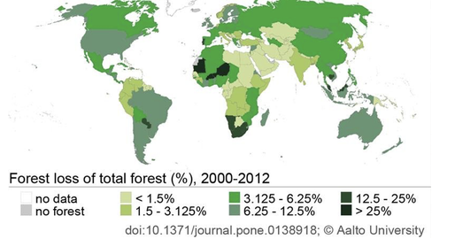 | Use the map in the bottom right corner:  Which areas of the world are losing the most forest?  How much forest loss is the United States experiencing?
Landfills  Traditional waste management techniques account for as much as ______ of greenhouse gas emissions. As the stuff we throw away breaks down, it leaks ___________ back into the air. | Approximately ___ % if the U.S Greenhouse gas emissions are associated with the energy used to produce, process, transport, and dispose of the food we eat and the goods we use. | Use the diagram to explain how modern landfill practices actually make emissions worse:
Human Population  Describe the growth curve. Do you think we can continue at this pace of growth? | What does the human population have to do with climate change? | Draw a graph of human population growth:

Effects
Global Temperatures  Earth's average surface temperature has increased by more than _______ since the 1880s. _________ of the warming has occurred in the last ___________. | Explain the link between greenhouse gasses and temperature rise. | According to the figure, what areas are experiencing the highest temp. rise? Why might that be especially harmful?
Sea Level Explain why rising temperatures would lead to higher sea levels. | Why does the sea level rising only a few inches cause so much worry? | Approximately ___ % of the world’s population lives in low lying coastal areas
Extreme Weather  Describe the extreme weather events that are becoming more frequent: | 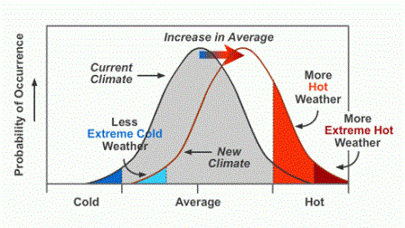 | Interpret and explain the information on the graph to the right:
Ecosystems  Summarize what changing climate is expected to do to animals who are adapted to their particular ecosystem: | How are coastal-ocean ecosystems expected to be affected? | 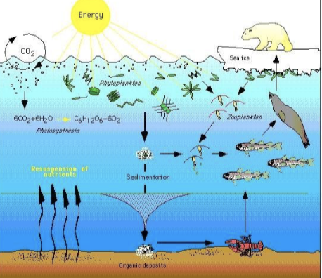
Human Health  Summarize how human health is expected to be affected by climate change: | Explain which age-groups will be most “at-risk” as climate change sets in. | Explain how insects will become more of a problem for human health:

Solutions
Renewable Energy  What is renewable energy and what makes it renewable? | Summarize the benefits of renewable energy: | From what source does most of the electricity come from in the U.S?  How do you expect this pie chart to change in 50 years?
Transportation  Summarize the EPA and DOT goals for passenger vehicles: | Using the figure, explain what has changed from 1974-2013 | Predict what environmentally friendly features cars will have in the future:
Infrastructure  Buildings worldwide contribute around _____ of all greenhouse gas emissions ( ____% in the U.S alone)  Why does an asphalt roof get warmer than a light-colored roof? | How would fixing and rebuilding highways help reduce emissions? | 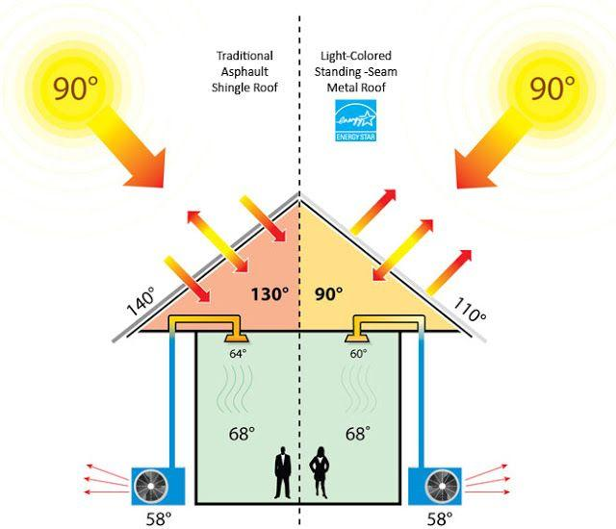
Sustainable Agriculture  How might buying locally grown food and organic (no fertilizer) food contribute to lowering carbon emissions? | 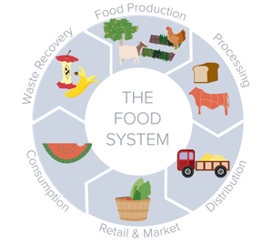  Caption this picture: | What part can you play in a sustainable agriculture system?
Reusing and Recycling Summarize what is meant by “reduce, reuse, recycle.” | List three facts from the infographic that surprise you. | How might buying used goods help slow the release of carbon emissions?

