Elements, Compounds and Mixtures
- Scientists like to classify things.
- One way that scientists classify matter is by its composition.
- Ultimately, all matter can be classified as mixtures, elements and compounds.
Why isn’t it a good idea to classify matter by its phases?
- Because one kind of substance can exist in more than one phase – such as H₂0. And matter changes phases rather easily.
Why isn’t matter classified according to its
physical characteristics, such as color?
- Scientists wouldn’t find it very useful to group gold, sunflowers, and the sun together.
- Scientists ask themselves these questions?
  - Is the matter uniform throughout?
  - Can it be separated by physical means?
  - Can it be separated by chemical means?
By asking these questions scientists can classify matter into:
- Elements, Compounds, Mixtures
Elements
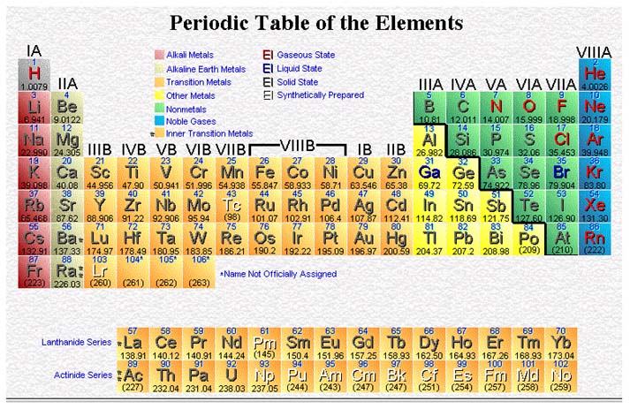
- Elements are the simplest pure substance.
  - An element can not be changed into a simpler substance by heating or any chemical process.
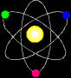
- The smallest particle of an element that has the properties of that element is called an atom.
  - An atom is the basic building block of matter.
- There are more than one hundred known elements in the universe listed on the periodic table of elements.
- An element is a pure substance (only 1 type of particle) that cannot be separated into simpler substances by physical or chemical means.

- All elements are made of atoms.
- Atoms of the same element are alike.
- Atoms of different elements are different.
- In 1813, a system of representing elements with symbols was introduced.
  - Each symbol consists of one or two letters.
  - Two letters are needed for a chemical symbol when the first letter of that element’s name has already been used.
Compounds
- Compounds are also pure substances.
- But compounds are made from more than one element.
- Water is a compound.
- Water can be broken down into simpler substances – hydrogen and oxygen.
Compounds Have Formulas
- H₂0 is the chemical formula for water, and H₂O₂ is the formula for hydrogen peroxide.
- The formula tells you which elements make up a compound as well as how many atoms of each element are present.
How to read a formula
H₂0
This is a subscript. It tells us how many atoms of that element exist in one unit of that compound.
Hydrogen is made of 2 H atoms and 1 O atom.
No subscript is used when only one atom of an element is present.
Let’s try it…
- Sulfuric Acid H₂SO₄
  - 2 Hydrogen
  - 1 Sulfur
  - 4 Oxygen
- Hydrogen Peroxide H₂O₂
  - 2 Hydrogen
  - 2 Oxygen
- Carbon Dioxide CO₂
  - 1 Carbon
  - 2 Oxygen
- Carbon Monoxide CO
  - 1 Carbon
  - 1 Oxygen

- Calcium Carbonate CaCO₃
  - 1 Calcium
  - 1 Carbon
  - 3 Oxygen
Mixtures
- A mixture is a combination of two or more substances where there is no chemical combination or reaction.
A mixture is a combination of two or more substances where there is no chemical combination or reaction.
Mixtures combine physically in no specific proportions.
They just mix.
Solids, liquids and gases can be combined to create a mixture.
Properties of Mixtures:
- Each substance in a mixture keeps its identity
- You can physically separate them
- They also contain elements, compounds, or both
- And they can be formed using any ratio of components
Mixtures may be homogeneous or heterogeneous
Homogeneous
- The prefix “homo” indicates the same
- Homogeneous mixtures have the same appearance and properties throughout the mixture
- Milk, toothpaste, and mayonnaise are homogeneous mixtures. They are also colloids.
Heterogeneous
- The prefix “hetero” indicates difference
- Heterogeneous mixtures consist of visibly different substances
Types of Mixtures
- There are THREE types of mixtures:
      - Solutions
      - Suspensions
      - Colloids
Solutions
- A solution is a mixture that appears to be a single substance, but it is actually composed of 2 or more substances that are distributed evenly amongst each other.
  - SOLUTIONS ARE HOMOGENEOUS
A solution has two parts
- The substance in the smallest amount and the one that DISSOLVES is called the SOLUTE
- The substance in the larger amount is called the SOLVENT - it does the dissolving
- IN most common instances water is the solvent
Suspensions
- A suspension is a mixture in which particles of a material are dispersed throughout a liquid or gas, but are large enough that they settle out.
  - SUSPENSIONS ARE HETEROGENEOUS
Colloids
- A colloid is a mixture in which the particles are dispersed throughout but are not heavy enough to settle out.
  - COLLOIDS ARE HOMOGENEOUS
Compounds vs Mixtures
Combine chemically Not chemically forming molecules combined
Combine in Can combine in set proportions any proportion
Separated chemically Separated physically
Element, Compound, or Mixture?
Rocks -- Element, Compound, or Mixture?
Copper -- Element, Compound, or Mixture?
Jelly Beans -- Element, Compound, or Mixture?
Table Sugar -- Element, Compound, or Mixture?
Diamond -- Element, Compound, or Mixture?
Tea -- Element, Compound, or Mixture?
Salt -- Element, Compound, or Mixture?
Neon Gas -- Element, Compound, or Mixture?
Salad -- Element, Compound, or Mixture?
Pure Water -- Element, Compound, or Mixture?
Aluminum -- Element, Compound, or Mixture?
Lemonade -- Element, Compound, or Mixture?
Silver -- Element, Compound, or Mixture?
Sand -- Element, Compound, or Mixture?
Challenge Time
- Are YOU an element, mixture or compound?

