The Atom & The Periodic Table of Elements
Atoms
- Matter is _______________ that takes up space and has ___________. All matter is made of _____________.
- ______________ are the basic building blocks of matter. They make up __________________ around us; Your desk, the board, your body, everything is made of atoms!
Subatomic Particle
Three subatomic particles make up every atom:
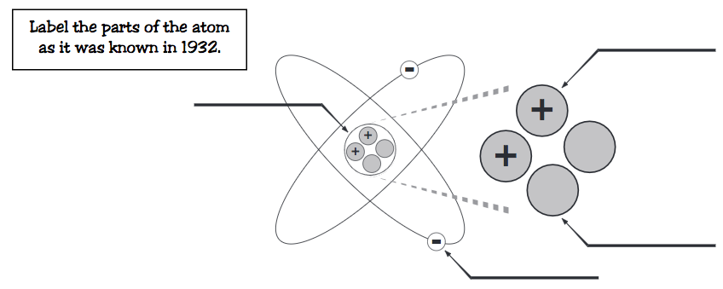
Atoms to Elements
- The _________________ and _____________________ of particles in an atom identifes an ________________.
- Every ________________ has a different number of atomic particles.
- Scientists have identified different materials containing different amounts of atomic particles and organized them into the __________________ ____________.
Elements
- Science has come along way since Aristotle’s theory of Air, Water, Fire, and Earth.
- Scientists have identified ____ naturally occurring elements, and created about _____ others.
- The elements, alone or in combinations, make up our ________, our world, our _______, and in fact, the entire ______________.
The most abundant element in the earth’s crust is ___________.
Periodic Table
- The periodic table __________________ the elements in a particular way. A great deal of information about an element can be gathered from its ______________ in the period table.
- For example, you can ____________ with reasonably good accuracy the physical and chemical _________________ of the element. You can also predict what other elements a particular element will ______________ with chemically.
- Understanding the organization and plan of the periodic table will help you obtain basic information about each of the _________ known elements.
Key to the Periodic Table
- Elements are organized on the table according to their atomic _____________, usually found near the top of the square.
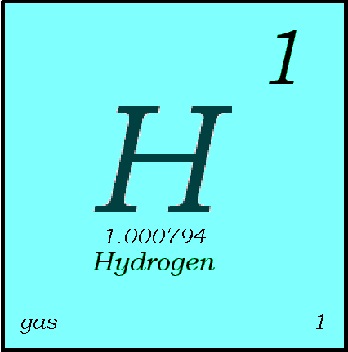
  - The atomic number refers to how many _________ an atom of that element has.
  - For instance, hydrogen has _ proton, so it’s atomic number is 1.
  - The atomic number is unique to that element. No two elements have the ________ atomic number.

What’s in a square?
- Different periodic tables can include various bits of information, but usually:
  - atomic _______________
  - _________________
  - atomic ___________
  - number of valence electrons
  - _____________ of matter at room temperature.

Atomic Number
- This refers to how many ________________ an atom of that element has.
- No two elements, have the __________ number of protons.
Atomic Mass
- Atomic Mass refers to the “_____________” of the atom.
- It is derived at by adding the number of ____________ with the number of _________________.
Atomic Mass Unit (AMU)
- The unit of measurement for an atom is an _____________. It stands for ___________ ___________ ___________.
- One AMU is equal to the mass of one ____________.
Atomic Mass Unit (AMU)
- There are 6 X 10²³ or 600,000,000,000,000,000,000,000 amus in one __________.
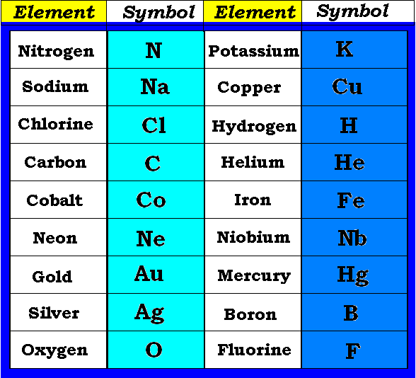
- (Remember that electrons are 2000 times smaller than one amu).
Symbols
- All elements have their own _________ symbol.
- It can consist of a _________ capital letter, or a capital letter and _________ or two lower case letters.

The elements of the periodic table can be divided into three main categories; _______________, _________________________, and _______________________ .

Properties of Metals
- Metals are good conductors of ___________ and electricity.
- Metals are __________________.
- Metals are _____________ (can be stretched into thin wires).
- Metals are _____________ (can be pounded into thin sheets).
- A chemical property of metal is its reaction with water which results in ___________________.
Properties of Non-Metals
- Non-metals are _________ conductors of heat and electricity.
- Non-metals are ____________ ductile or malleable.
- Solid non-metals are brittle and _______________ easily.
- They are ___________.
- Many non-metals are _____________.
Properties of Metalloids
- Metalloids (metal-like) have properties of ____________ metals and non-metals.
- They are _______________ that can be shiny or dull.
- They conduct heat and electricity _____________ than non-metals but _____________ as well as metals.
- They are ________________ and malleable.
Elements in the periodic table are also grouped into ___________, which are the _______________. Elements in families have _______________ properties.
The elements are also categorized into _______________ or horizontal _____________.
Elements in periods do _____________ have similar properties.

